**SALARY BY TITLE AND COUNTRY DATABASE**

*# Write a sql query to get all the details of the salary table*

SELECT *

FROM Salary1;

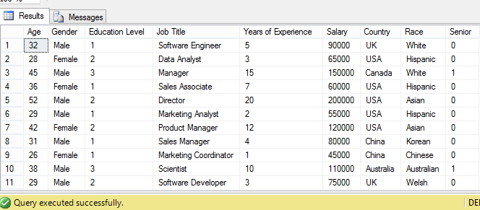

*# Write a query to get all the distinct job titles from the salary table*

SELECT DISTINCT Job Title

FROM Salary1;

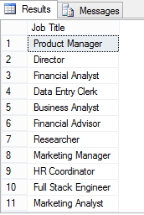

*# Write a query to find the total number of distinct jobs provided in the table.*

SELECT COUNT(DISTINCT Job Title) AS Total_Number_of_Jobs

FROM Salary1;

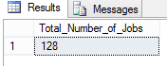

*# Write a query to find the total number of male and female employees from the salary table.*

SELECT COUNT(Gender) AS Total_No_of_Employees, Gender

FROM Salary1

GROUP BY Gender;

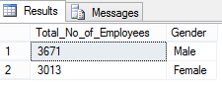

*# Write a sql query to find the total number of employees in different races provided in the salary table.*

SELECT Race, COUNT(Race) AS Number_of_Employees

FROM Salary1

GROUP BY Race

ORDER BY COUNT(Race) DESC;

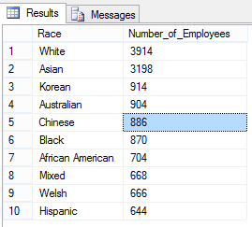

*# Write a sql query to find the maximum and minimum salary.*

SELECT MAX(Salary) AS Maximum_Salary, MIN(Salary) AS Minimum_Salary

FROM Salary1;

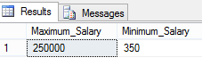

*# Write a sql query to find the total number of employees working in different countries from the salary table.*

SELECT COUNT(Country) AS Total_No_of_Employees, Country

FROM Salary1

GROUP BY Country;

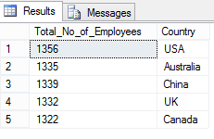

*# Write a sql query to find all the details of the top 10 employees with highest salary from the salary table.*

SELECT TOP 10 *

FROM Salary1

ORDER BY Salary Desc;

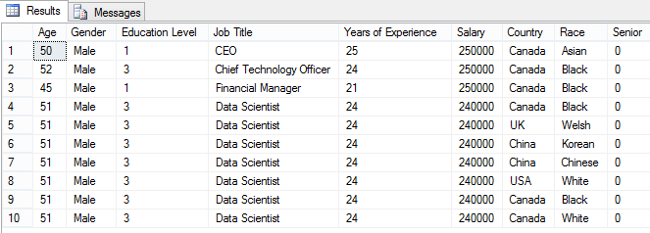

*# Write a sql query to find the details of 10 employees with minimum salary from the salary table.*

SELECT TOP 10 *

FROM Salary1

ORDER BY Salary;

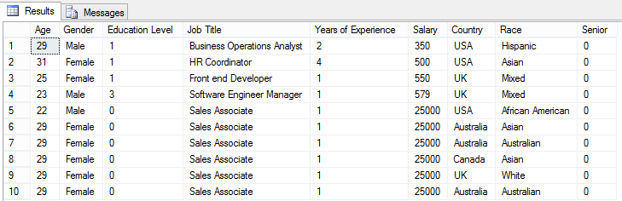

*# Write a sql query to find the list of top 10 jobs with the highest salary from the salary table.*

SELECT DISTINCT TOP 10 [Job Title], MAX(Salary) AS Salary

FROM Salary1

GROUP BY [Job Title]

ORDER BY MAX(Salary) DESC, [Job Title];

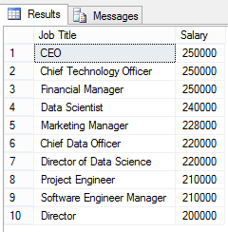

*# Write a sql query to find the list of 10 jobs with minimum salary from the salary table.*

SELECT DISTINCT TOP 10 [Job Title], MIN(Salary) AS Salary

FROM Salary1

GROUP BY [Job Title]

ORDER BY MIN(Salary), [Job Title];

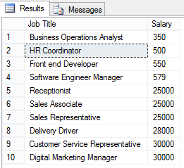

*# Write a sql query to find the top 10 job titles with maximum number of employees.*

SELECT TOP 10 [Job Title], COUNT([Job Title]) AS No_of_employees

FROM Salary1

GROUP BY [Job Title]

ORDER BY COUNT([Job Title]) DESC;

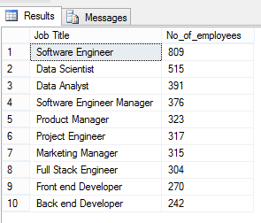

*# Write a sql query to find the overall average salary in different countries.*

SELECT [Country], AVG([Salary]) AS Average_Salary

FROM Salary1

GROUP BY [Country]

ORDER BY AVG([Salary]) DESC;

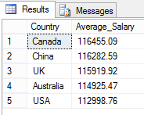

*# Write a sql query to find the correlation among age, years of experience and salary from the salary table.*

SELECT [Age], [Years of Experience], CAST(ROUND(AVG([Salary]),2) AS numeric(19,2)) AS Average_Salary

FROM Salary1

GROUP BY [Age], [Years of Experience]

ORDER BY AVG([Salary]) DESC;

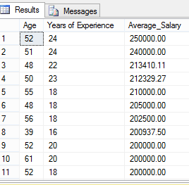

*# Write a sql query to find the correlation among education level, years of experience and salary from the salary table.*

SELECT [Education Level], [Years of Experience], CAST(ROUND(AVG([Salary]),2) AS numeric (19,2)) AS Average_Salary

FROM Salary1

GROUP BY [Education Level], [Years of Experience];

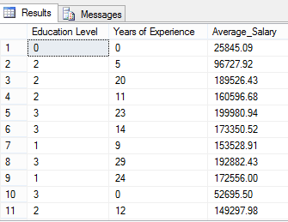

*# Write a sql query to find the number of employees in different age group from the salary table.*

SELECT Age, COUNT(Age) AS Number_of_Employees

FROM Salary1

GROUP BY Age

ORDER BY COUNT(Age) DESC;

